**WIM USABILITY QUESTIONS OVER THE YEARS**

*The homepage of a good website should attract people, it’s the window of the shop and if the first visit goes not so well the website has failed its goal and users’ return rate goes down. This is the reason why the homepage is so important for websites. Let’s analyse this homepage to discover if it is well designed*.

The first thing to observe are if the 6 informative axes are present. If there are, the homepage gives to the user the main information to understand the context of the site.

* **WHERE the user is**: there is no breadcrumb (that should be always present) but since this is the homepage and we are not observing a deep linking case this could be acceptable. From the title of the page a user can understand that is in the site of Bologna Museum.
* **WHO is behind the site**: generally, this information can be captured by the logo, here the logo is well positioned because it is exploiting one of the best points of users attraction. From the logo we probably understand that the city of Bologna is behind this site. There are also some contacts visible in the homepage and also these confirms that Bologna is the “owner” of the site.
* **WHY a user should stay**: there is a menu voice “*10 reasons for an unforgettable visit*” that seems to be what we are looking for, but it is a gambling click. It is true that from the phrase it could be what we want but it is not a warranty: a user has to hope that he will find this information. Apart this voice menu there is no other information about that and this is not good because a good website should persuade users to stay.
* **WHAT the site offers**: a good homepage should give to the user all possible destinations of the site and this is present as we can note from the left menu.
* **WHEN, which are the latest news**: as we can note there is a partial-visible section called “*news*”, to see it entirely a user should scroll the page to obtain this information (if present, we can just see images there 🡪 a type of “gambling scroll”)
* **HOW to arrive where users want**: the menu answer to this question, a user can see all pages reachable and there is also a search functionality (that respect the standard of the web) where a user can collect other information.

Beyond the informative axes we can note that there is a problem with the English translation. All elements should be clear to foreign visitors but the logo in the top-left corner isn’t, as the phrase in the middle of the page and the TripAdvisor reward on the right side.

There is also a big slider that is put immediately after the title, in a sense that is the first important element to insert, also more important than the WHEN informative axis. A slider, apparently, with no justification because it seems to be just a collection of images that gives no other information to the user and it is also skipped in the scanning phase due to the zapping effect.

The text is not much, it respects the user timers, it has a standard font and the text-background contrast is good, so it is readable.

*The homepage of a good website should attract people, it’s the window of the shop and if the first visit goes not so well the website has failed its goal and users’ return rate goes down. This is the reason why the homepage is so important for websites. Let’s analyse this homepage to discover if it is well designed*.

The first thing to check is if the 6 informative axes are present. If they are, the homepage gives to users all the information to understand better the website context.

* **WHERE did the user arrive?** There is no breadcrumb which a user can use to understand where he is but since this is the homepage and not a deep linking case this could be acceptable. The homepage is difficult to read but from the title a general user can understand that the website is about safety training for police and public.
* **WHO is behind the website?** If we analyse the entire homepage we cannot find information about the author of the site. There is a link voice “CONTACT US” where we could find this information but since this is not visible it’s a type of gambling click because the user is forced to click hoping to find what he wants, so we cannot say that the WHO axis is present.
* **WHAT the site offers?** The homepage is characterized by many and many links, in reality in the homepage there are just links. The website seems to offer different things about safety training such as practice courses, manuals, schedules (of the courses?) but all of this is not so clear due to a bad design choice that just confuses the user.
* **WHY does the user stay?** There are no explicit reasons about why a user should stay in the website. There is a phrase, that seems to be like a slogan, immediately under the title that says “*Train weekly of fight weakly*”. The authors maybe thought that just this phrase was enough to attract users but this is not television, it’s the web, things work in a different way and this is not the appropriate way to insert the WHY axis. There is also to note that this slogan has been inserted in a big useless image that is immediately deleted by the user during the scanning phase.
* **WHEN? Which are the latest news?** This information is missing, there are no elements that represent this axis.
* **HOW can the user arrive to other pages?** As said before, there are many links in the homepage that represent all or most of the website pages. It’s difficult to identify a main menu, the entire homepage seems to be a big menu. There are some links inside a table and some outside and apparently for no reason, this just confounds users, maybe there is a meaning behind but just the authors can know it!

There are not much other considerations about this homepage. Some informative axes are missing and this is a problem where a user tries to extract the context about the website. Again, the scanning phase here it’s really challenging because, beyond the images that are skipped, the homepage is just a list of links and users can just try to make hypothesis about their content.

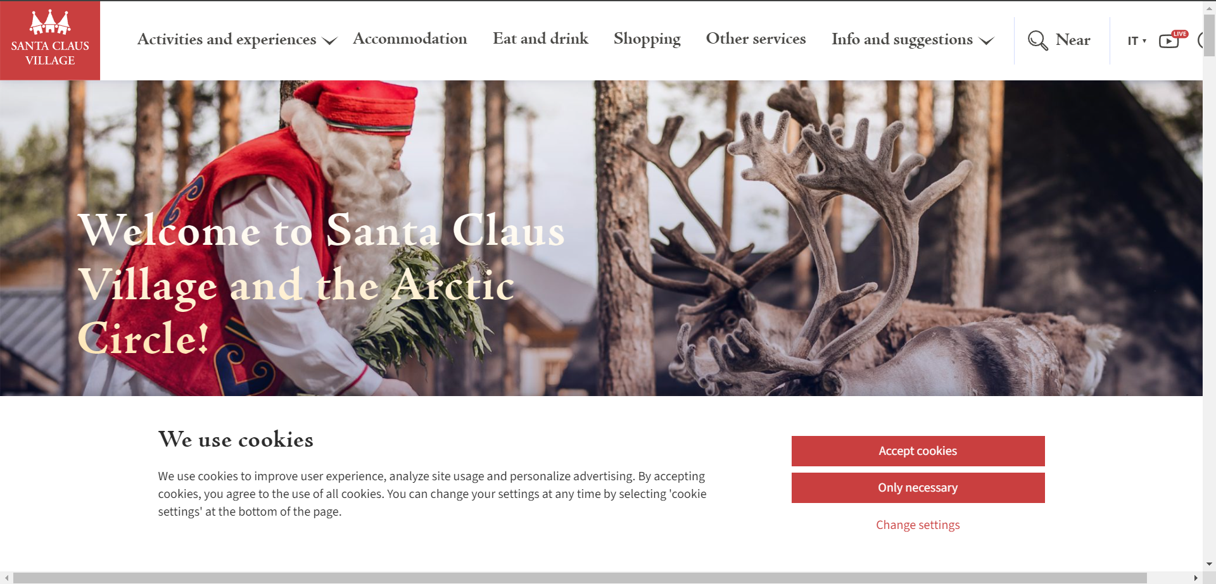

*The homepage of a good website should attract people, it’s the window of the shop and if the first visit goes not so well the website has failed its goal and users’ return rate goes down. This is the reason why the homepage is so important for websites. Let’s analyse this homepage to discover if it is well designed*.

The first thing to check is if the 6 informative axes are present. If they are, the homepage gives to users all the information to understand better the context of the website.

* **WHERE the user arrived?** There is no breadcrumb which the user can use to better understand where he is but, since this is the homepage and not a deep linking case, this could be acceptable. From the top-left logo and the homepage title a user can assume that this website describes a Santa Claus Village that people can visit.
* **WHO is behind the site?** It’s not clear who is the author of the site, this information is missing.
* **WHAT the site offers?** A good homepage should provide to users all possible pages that can visit and for this there is a top menu characterized by many voices. Anyway, this menu is not so clear, there are ambiguous voices like “ACCOMODATION” and “SHOPPING”.

It is not clear if the ACCOMODATION voice refers to a booking system or just to a description about the accommodation options so user can’t predict what he will see (example of gambling click).

Talking about the SHOPPING, it is not clear if the website has a small e-commerce part or if the shop is inside the village and this is a problem because a user can’t predict what he will see if he visits that page (example of gambling click).

* **WHY should the user stay?** The homepage doesn’t provide this information, so it’s not giving a good reason for why users should stay. Maybe users can find this information in the “ACTIVITIES AND EXPERIENCES” menu voice but, again, this is a gambling click so we cannot be sure about that.
* **WHEN? Which are the latest news?** As the WHO and WHEN axes, also this information is missing.
* **HOW the user arrives where he wants?** The top menu answers to this question (with the limits seen in the WHAT axis), users can collect other information visiting pages which are available. It seems that there is also a search functionality but it is not clear if it is a search option, this because it doesn’t respect the web standard (*search* label + search icon) so we cannot be sure about that.

Also talking about the information, we analysed a lot the homepage and we don’t even know where the village is, that is the main information that users want to know. This is a problem because the homepage (and so the website) is not giving the main information.

We have also two serious problems here: cookies pop-up and the presence of the horizontal scrolling. Talking about the pop-up this is bad because we are asking to users to accept something before they see what the website is offering, this is a serious trust problem that decreases the users’ return rate. It’s like before entering in a real-life shop, someone forces us to sign something to enter and see what the shop makes available; this cannot work! And the worst thing is that there isn’t a visible way to close it.

We can also note the presence of the horizontal scroll which is one of the most hated things by users, this because we are used to use just the vertical scroll when we surf on the web. We are introducing a new dimension to manage; the moving space becomes bidimensional and this increases the computational effort required to stay in the site and we know that users prefer easy things.

*The homepage of a good website should attract people, it’s the window of the shop and if the first visit goes not so well the website has failed its goal and users’ return rate goes down. This is the reason why the homepage is so important for websites. Let’s analyse this homepage to discover if it is well designed*.

The first thing to check is if the 6 informative axes are present. If they are, the homepage gives to users all the information about the website context. But here we are not able to see much of the homepage, it’s all covered by, not one but two big size pop-ups and this is terrible because pop-ups are one of the most hated things on the web. Pop-ups lead to important trust problem, if there is no way to close them users has to accept the conditions to see what there is behind them and users’ return rate goes down.

One of the two pop-ups can be closed while the other not. If we assume that user is patient (really rare) and tries to close the middle pop-up we can analyse what we see and we firstly can check about the informative axes.

* **WHERE the user arrived?**
* **WHO is behind the site?**
* **WHAT the site offers?**
* **WHY should user stay?**
* **WHEN? Which are the latest news?**
* **HOW can user arrive where he wants?**



